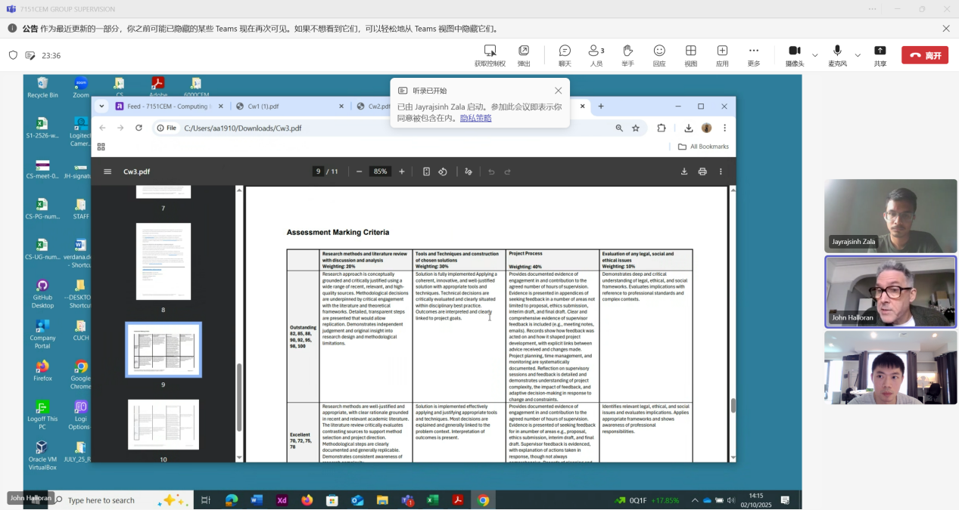

Yuhao Wu
0 minutes 7 seconds0:07
Yuhao Wu 0 minutes 7 seconds
Yes.

John Halloran
0 minutes 21 seconds0:21
John Halloran 0 minutes 21 seconds
Question how does your data help to answer that research question? OK, these is these sorts of questions which are quite broad questions. If you can answer those questions, you're doing well, OK.
John Halloran 0 minutes 37 seconds
Now don't worry too much about that.
John Halloran 0 minutes 43 seconds
As I say, it's a learning process. You know, you had 12 weeks of of of this module, actually a bit less now 10 weeks, right? And it will be a learning process. I'll be meeting you guys every week anyway.
YW

Yuhao Wu
0 minutes 53 seconds0:53
Yuhao Wu 0 minutes 53 seconds
Oh, thank you.

John Halloran
1 minute1:00
John Halloran 1 minute
The first half of the module is probably going to be group supervisions, but after that they will go individual. You will also need to create a presentation. You will each present to me and a second supervisor.
John Halloran 1 minute 17 seconds
We will make sure that you're ready to give that presentation and I'll give you a good idea of what will happen in that presentation, right? Same with the dissertation. I will read your draught dissertations and give you feedback at at least once, and probably twice. So I'm here.
John Halloran 1 minute 37 seconds
To give you lots of support to be successful through the supervisions and and with the assessment.
John Halloran 1 minute 44 seconds
Is that OK?
YW
Yuhao Wu
1 minute 45 seconds1:45
Yuhao Wu 1 minute 45 seconds
Oh yes, thank you.

Jayrajsinh Zala
31 minutes 11 seconds31:11
Jayrajsinh Zala 31 minutes 11 seconds
Isn't.
YW
Yuhao Wu
31 minutes 11 seconds31:11
Yuhao Wu 31 minutes 11 seconds
Mm-hmm.
Yuhao Wu 31 minutes 15 seconds
It's real. I don't have these questions.
Yuhao Wu 31 minutes 21 seconds
Hey wait, I'm in this.
Yuhao Wu 31 minutes 24 seconds
College resort engineer.
Yuhao Wu 31 minutes 28 seconds
And online.
Yuhao Wu 31 minutes 42 seconds
It's three-year.

Jayrajsinh Zala
31 minutes 47 seconds31:47
Jayrajsinh Zala 31 minutes 47 seconds
Do you have a different interface?
YW
Yuhao Wu
31 minutes 53 seconds31:53
Yuhao Wu 31 minutes 53 seconds
Yes, I'm checking now.

Jayrajsinh Zala
31 minutes 57 seconds31:57
Jayrajsinh Zala 31 minutes 57 seconds
OK.
YW
Yuhao Wu
32 minutes 6 seconds32:06
Yuhao Wu 32 minutes 6 seconds
Oh.
Yuhao Wu 32 minutes 10 seconds
Maybe you are registered registered now it's not your exist application.
Yuhao Wu 32 minutes 23 seconds
It's different from different from my.

Jayrajsinh Zala
32 minutes 26 seconds32:26
Jayrajsinh Zala 32 minutes 26 seconds
Yes.
YW
Yuhao Wu
32 minutes 28 seconds32:28
Yuhao Wu 32 minutes 28 seconds
Press strength.

Jayrajsinh Zala
32 minutes 28 seconds32:28
Jayrajsinh Zala 32 minutes 28 seconds
OK.
Jayrajsinh Zala 32 minutes 34 seconds
And.
YW
Yuhao Wu
32 minutes 42 seconds32:42
Yuhao Wu 32 minutes 42 seconds
University university ID.
Yuhao Wu 32 minutes 50 seconds
It's real.

Jayrajsinh Zala
32 minutes 52 seconds32:52
Jayrajsinh Zala 32 minutes 52 seconds
I think I think you got that you are talking about this one. If I record this engineer and here I can something like that.
YW
Yuhao Wu
33 minutes 9 seconds33:09
Yuhao Wu 33 minutes 9 seconds
Oh yes. Silence. Semester. September. Oh, yes, that's correct.

Jayrajsinh Zala
33 minutes 11 seconds33:11
Jayrajsinh Zala 33 minutes 11 seconds
Yeah.
Jayrajsinh Zala 33 minutes 16 seconds
Yes.
Jayrajsinh Zala 33 minutes 18 seconds
And I just have to like computing, yeah.
YW
Yuhao Wu
33 minutes 24 seconds33:24
Yuhao Wu 33 minutes 24 seconds
Yes.

Jayrajsinh Zala
33 minutes 25 seconds33:25
Jayrajsinh Zala 33 minutes 25 seconds
And just say say when next.
YW
Yuhao Wu
33 minutes 28 seconds33:28
Yuhao Wu 33 minutes 28 seconds
Yes.

Jayrajsinh Zala
33 minutes 31 seconds33:31
Jayrajsinh Zala 33 minutes 31 seconds
OK. And then I have to write everything, whatever it's required.
YW
Yuhao Wu
33 minutes 36 seconds33:36
Yuhao Wu 33 minutes 36 seconds
Yes, there has to answer the questions, but if you are confused about something, do you remember Peters videos?

Jayrajsinh Zala
33 minutes 39 seconds33:39
Jayrajsinh Zala 33 minutes 39 seconds
OK.
YW
Yuhao Wu
33 minutes 46 seconds33:46
Yuhao Wu 33 minutes 46 seconds
Yeah, last semester.

Jayrajsinh Zala
33 minutes 47 seconds33:47
Jayrajsinh Zala 33 minutes 47 seconds
How's it?
Jayrajsinh Zala 33 minutes 49 seconds
Yeah.
YW
Yuhao Wu
33 minutes 50 seconds33:50
Yuhao Wu 33 minutes 50 seconds
Oh, I will send you the link. Wait a minute.

Jayrajsinh Zala
33 minutes 55 seconds33:55
Jayrajsinh Zala 33 minutes 55 seconds
An issue?
YW
Yuhao Wu
33 minutes 57 seconds33:57
Yuhao Wu 33 minutes 57 seconds
Bing is quite useful from his his informations they ask.
Yuhao Wu 34 minutes 19 seconds
Oh, I send you the link and yeah.

Jayrajsinh Zala
34 minutes 22 seconds34:22
Jayrajsinh Zala 34 minutes 22 seconds
Yeah, I got.
YW
Yuhao Wu
34 minutes 30 seconds34:30
Yuhao Wu 34 minutes 30 seconds
And the first video let me chat.
Yuhao Wu 34 minutes 55 seconds
And I have sent you the pictures.
Yuhao Wu 35 minutes 2 seconds
You can trust the first videos and the type I I also send yours.

Jayrajsinh Zala
35 minutes 10 seconds35:10
Jayrajsinh Zala 35 minutes 10 seconds
OK.
YW
Yuhao Wu
35 minutes 12 seconds35:12
Yuhao Wu 35 minutes 12 seconds
You can finish step by step. You has any question you can ask Miss or ask the supervisor.

Jayrajsinh Zala
35 minutes 19 seconds35:19
Jayrajsinh Zala 35 minutes 19 seconds
Yeah, sure, sure.
Jayrajsinh Zala 35 minutes 25 seconds
Thank you bro. Have a nice day. Yeah, you too. Bye. Bye. Take care.
YW
Yuhao Wu
35 minutes 27 seconds35:27
Yuhao Wu 35 minutes 27 seconds
And thank you. Have a nice day. Bye bye.

